

Answers to the Word Scramble: Red Shrimp Restaurant, Cricket, Garzoni Garden, merry-go-round, Fairy, marionette, labyrinth, zipline, theater, Whale, Villa Garzoni, labirinto, Mangiafuoco, La Lumaca, Corvo, Piazza dei Mosaici, giostra, Serata delle Farfalle, carabinieri

**Pinocchio!**

**Fun Stuff!**

April 22 & 23, 2023

Casa Italiana, Los Angeles

Produced by Opera Italia

[www.operaitaliala.com](http://www.operaitaliala.com)

@operaitaliala

**In Collodi, Italy, the town where the author was a child, there is a wonderful Parco di Pinocchio (Pinocchio Park) ~ you can wander and explore, and find many of these characters…you can climb inside the giant whale, and go on a zipline too, for fun!**

**Most of you have heard of the Cricket, the Cat and the Fox who are talking animals in Pinocchio’s adventures…but did you know that the original story has 34 talking animals? Yes!**

**La Lumaca (the Snail), il Serpente (the Snake), la Libellula (the Firefly), il Falco (the Falcon), il Can-barbone (the Poodle named Medoro), and many more.**

**PINOCCHIO was written only a short time after Italy became a new, unified country. It was a big project to educate all children to read and write in standard Italian. Pinocchio the puppet stands for the new nation of Italy, struggling and learning to be modern and strong.**

**So who is PINOCCHIO?…the original story starts:**

**C’era una volta… (Once upon a time there was…)**

**---Un re! (A king!)**

**---No, ragazzi, avete sbagliato. C’era una volta un pezzo di legno. (No children, you are mistaken. Once upon a time there was a piece of wood.)**

**Written by Carlo Collodi in 1883, Pinocchio is the story of the wooden puppet who becomes a real boy only after he walks, runs and swims through one adventure after another. Pinocchio’s father, Geppetto, is a humble woodcarver – and he truly wants his puppet-son to go to school and get an education ~**

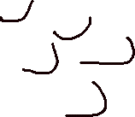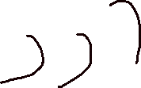

***What is the promise he makes to his father Geppetto?***

____________________________________________________________

____________________________________________________________

**VORTEX Riddle**

**Pinocchio is starting into the vortex of a terrible whirlpool! The whirlpool has sucked up something important that the brave puppet says. Start on the outside and work to the center of the vortex. Write down only every other letter. When you get to the center, go back in the other direction and write down the letters you didn’t get the first time.**

**The Cat and the Fox blindfold Pinocchio and turn him round and round to make him dizzy…**

**…with open eyes, you can help Pinocchio make it through the maze where his real friend, the Talking Cricket, is waiting !!!**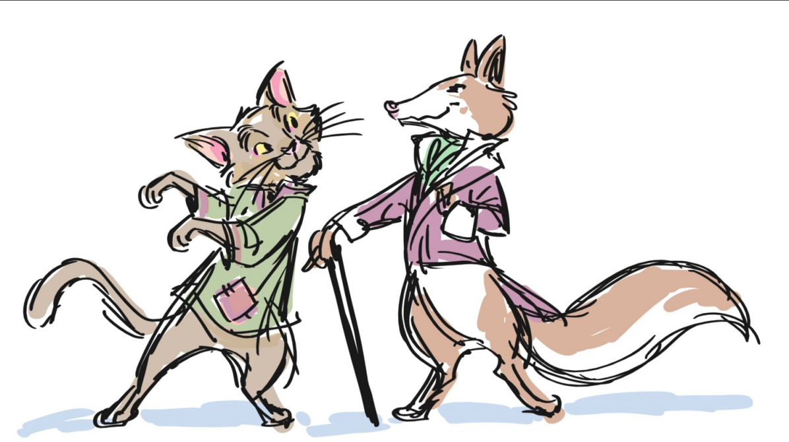



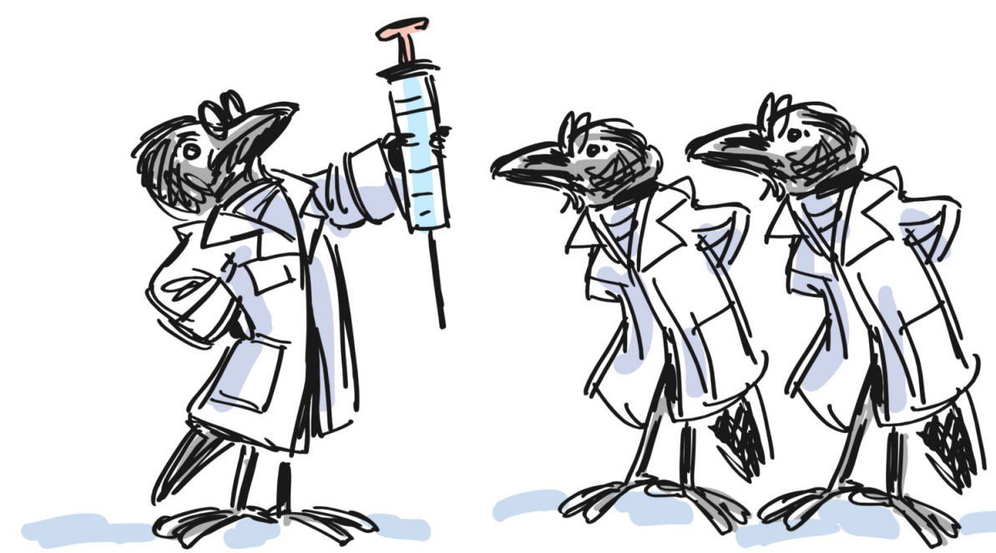

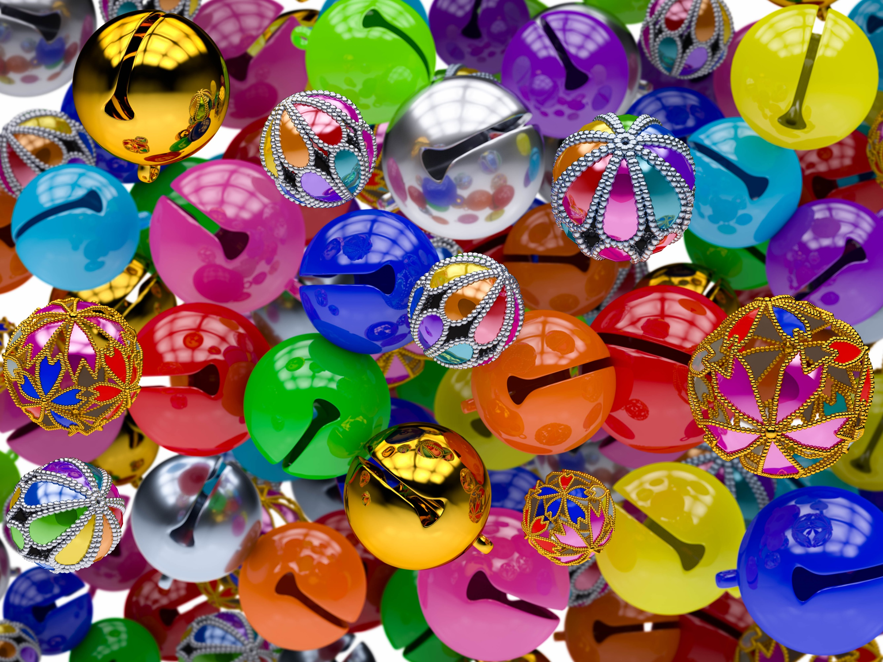

**Un Grillo che sa parlare!**

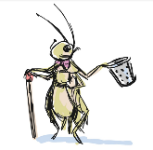

**Il Paese dei Balocchi!**

**Natalia Valli**

I Tre

Corvi-Medici

**C’era una volta…**

**“Un Re!”**

**No, avete sbagliato –**

**C’era una volta un pezzo di legno…**

**…Gli Ucelli Neri…**

**La Ninna Nanna della Fata**

**First time at the Opera?**

**Arrive a little early**. Give yourself time to enter the theater, find your seats and read your program. Make sure you use the restroom and get a drink of water before the show starts.

**Whisper**. At the Opera, you will see and hear many amazing things – and we all want to share with our social buddies. Try to remember all those magical moments and you can chat at the Intervallo (Intermission) or afterwards.

**Turn off your phones**. It’s hard to appreciate all the hard work of the musicians, singers, and dancers if you are looking at a phone screen. Please turn off all phones and tablets before the opera begins.

**Applaud**! Applause is how audiences show appreciation for the artistry of the performers. In Opera, there are many times to practice your clapping. After a short variation, or solo melody, a singer may finish singing and take a small bow. Sometimes at the end of the Opera when singers and musicians take their final bow, the audience shouts “Brava” for female performers and “Bravo” for the male performers to show appreciation and admiration.

**Ask Any Questions**. When you arrive, you will meet members of Opera Italia’s staff, including ticket takers, ushers and security. If you have any questions or need any help, please come and talk with us. Have Fun! Don’t forget to enjoy yourself. Operas can be dramatic, romantic, and really funny.

**Collodi:** *things to do and see!*

**Word Scramble**

English/Inglese:

dre prshmi rrtnesuaat___________ nihtlaryb __________

Ctketirc________________ nielzip_____________

zionGar drneGa___________ rteehat ____________

yrrem-og-rnduo ________________ healw ____________

yriaF_______________

teetnmario________________

Italiano:

laiVl ioazrG_________________

intoialbr_________________

oouaiacfgnm___________________

La aaucmL___________________

vrCoo______________

azzaiP ide iiaocsm_________________

artsoig_____________ ieiiaarnbrc_______________

aaetrS lleed eaallfrF_________________

answers on page_

**Welcome to Opera Italia ~ LA!**

…and Thank You!

…for bringing your parents to the Opera!

My name is Francesca Taylor, and I am the Founder and Producer of Opera Italia. (Being Founder and Producer means that I run the Opera and engage wonderful and talented people to play and sing and make the opera come to life. I work with the delightful staff and clergy of St. Peter Italian Church and the Casa Italiana to make this beautiful auditorium a fun place to experience Opera) Opera is one of the greatest of all artforms in Italian culture, and I learned to love opera from my Italian grandparents.

Like many of you, I studied music as a child. I played in recitals and sang in my church and University choirs. I have three daughters who are now grown, and when they were children, I brought them here to Casa Italiana to see beautiful operas and to hear the singing of La Bella Lingua (the beautiful language, which is Italian)

Please go around to all the activity tables today – you see them right here in the Casa. At each table there is something different to do; and be sure to take your picture in front of the GREAT backdrop of Collodi.

If you enjoy today’s performance, don’t forget to yell “BRAVO!” during the bows.  And please ask your parents to check out [www.operaitaliala.com](http://www.operaitaliala.com) to sign up to receive information about Opera Italia’s family programs. We do “Opera Night for Kids” every month, and this summer we will have a SUPER FUN Opera Camp!

Enjoy your Opera Adventure today, and please return soon!Best wishes,

Dr. Francesca

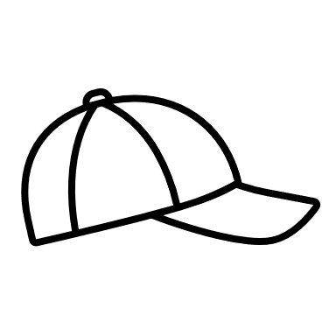



**Costume Fun!**

Pinocchio and Lucignolo have been asked to be in another show together.

Imagine new costumes for them ~ the sky’s the limit!

**“Il Mondo e’ Pien di Meraviglie –**

**The World is Full of Wonders”**

**Natalia Valli, the composer of PINOCCHIO! The Lyric Opera, left a message for you in this piece of sheet music. A vertical line means a space between words.**

The Cat is up to his old tricks…

He’s hidden a message in the image below. hold this page at eye level and tilt it back slowly until you can read what he has written.

Hint: the letters are in black!

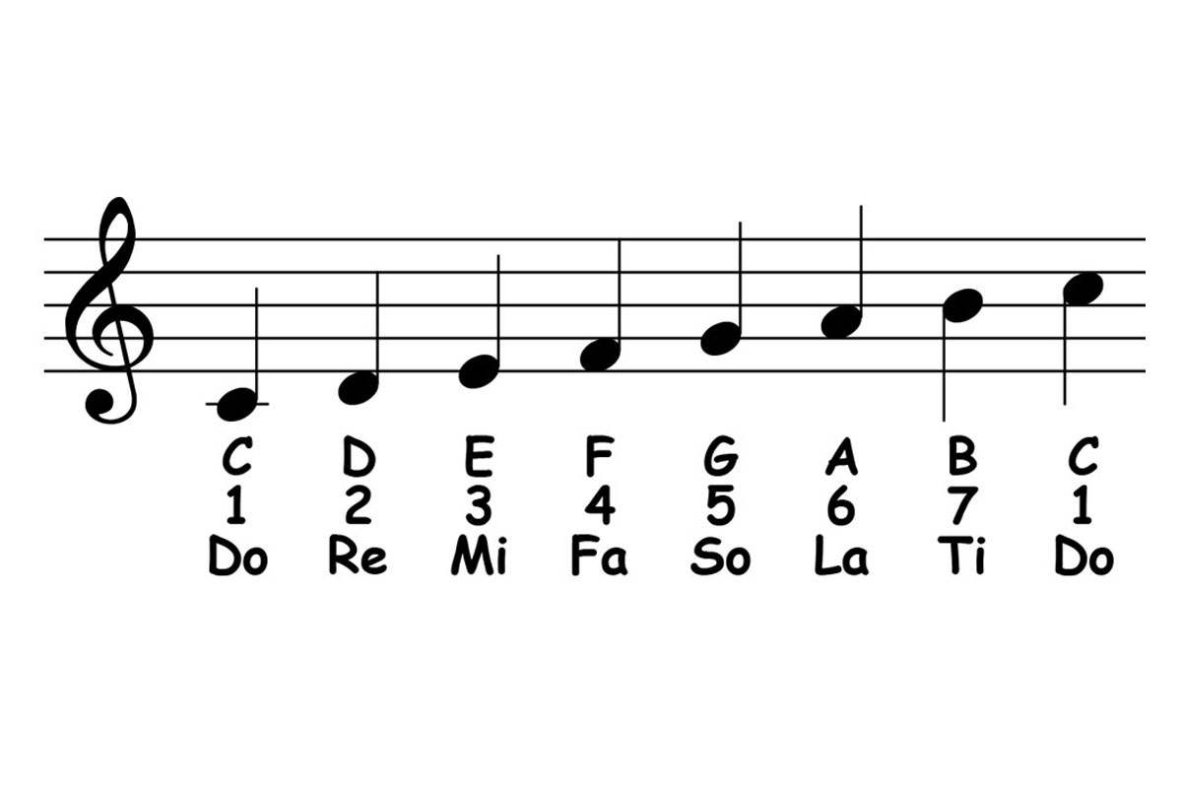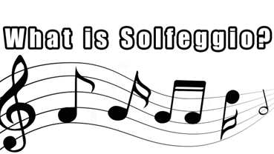

**Sight**

**Reading**

**Factory!**

**Try it!!**

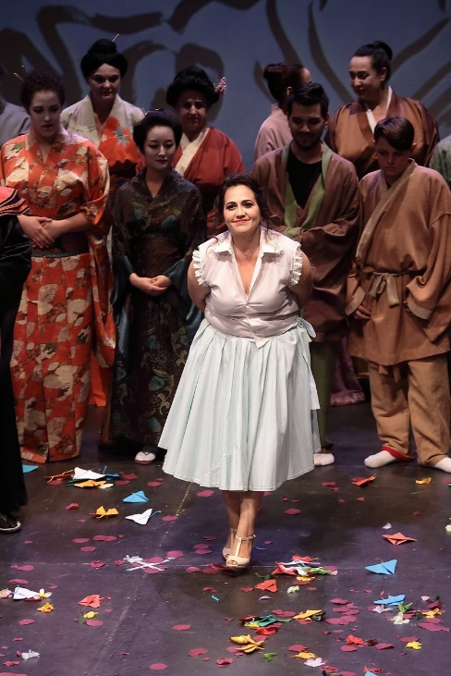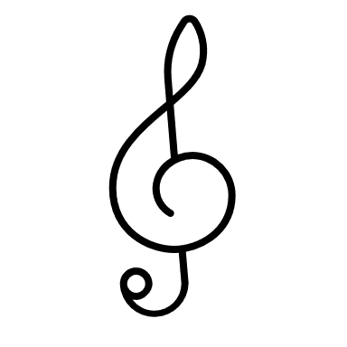

**A Singer’s Journey…**

**Up close with**

**Gabriella Rodmac**

**Soprano**

I’ve always been fascinated by opera singers and always thought only people with “special powers” could do that. I’ve always loved singing in general and back in the early 2000’s I was obsessed with Italian superstar Laura Pausini so I learned almost every song she ever sang. I went to a singing teacher and sang those for him, and he turned to me and said: You need to sing opera. I almost chuckled at the idea since I thought that was for people from another world hehehe. He gave me an operatic Italian aria to study, and I immediately fell in love and felt that it was quite fitting for my voice. And thus, my journey in opera began. Never in my wildest dreams would I have thought it would end up bringing me to Italy where I live now!

**Fun Facts:**

**First ever aria**: O Mio Babbino Caro Lauretta’s aria from Puccini’s trittico piece: Gianni Schicchi.

**First ever [fully staged opera] role**: Carmen by Georges Bizet at the Street Opera Festival in Tijuana, Mexico.

**Favorite Role**: Tosca, from Puccini’s Tosca, although I like so many others!

**How many hours do you sing each week**: It is important for singers to work on their instrument constantly so At least 7 times a week but sometimes more, especially when having an upcoming performance.

**Most Challenging Role**: Dona Elvira from Mozart’s Don Giovanni. She has 3 arias, and she sings in the entire opera! I love performing this role though!

**My Favorite Opera**: Well this goes together with my absolute favourite role: Puccini’s Tosca. If I had to pick another one I’d go for Verdi’s Il Trovatore… such a masterpiece!

**How does it work, being an Opera Singer?** 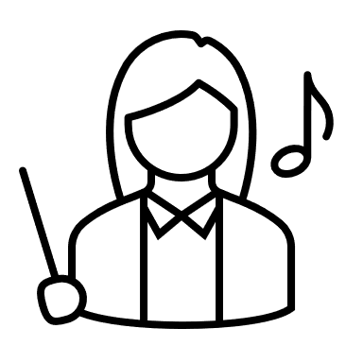

It is one of the most challenging things! You have to be extremely disciplined and committed. You have to give up so many things including most of the “normal” things people do and it can be a bit hard at times with all the traveling and taking care of yourself and your vocal instrument but as soon as you go on stage you realize that it’s all worth it. To know that I am a part of the magical music-making process and to know that my voice has the power to make so many people happy just fills my heart and makes me want to work harder everyday.

